**Parametric Pattern Editing Tool**

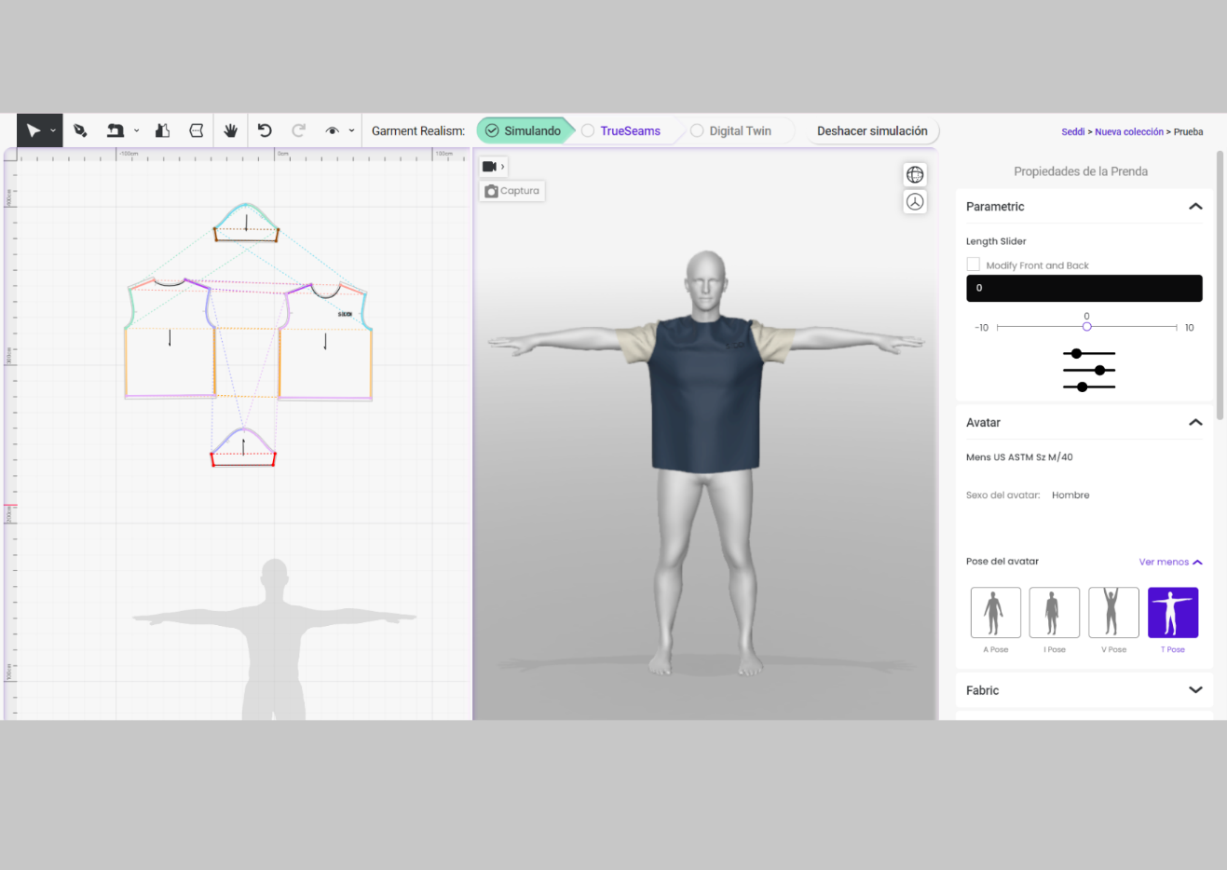

Our idea is that you can add the pattern you want and, depending of the type of garment, you can modify different parameters with a slider. For example, in a t-shirt: the length, width, width of the neck, or the sleeve curve and cap. With sliders you would modify the pattern, is it is automatically updated in the scene. For these edits we will have to take into account the grading rules, so that although they are not size changes of the entire garment, they are taken into account to adjust the curves. We would also take into account the properties of the avatar to avoid collisions.

Some considerations with the **designers**:

- POMs (Points of messure) aren’t defined yet in Author. It is very important that the user can define their POMs, as one company might use a different position for the chest than another company. For Master’s Tesis we can focus on specific t-shirt and pant patterns and create manually the connections of the pieces.

- Before or after sewing?

In the main use case, the user edits the measurements in the final garment to see how the garment reacts as a whole. But the user will want the option to edit the measurements of a pattern when it has not yet been sewn.

Users should be able to use the sliders before, during and after sewing. We should not have a restriction until the garment has run TrueSeams, then this kind of editing will be blocked -Harrison

In this case is a service that you offer after sewing. That's how I would work with this.- Loreto

- Option to Symmetrical or not?

Symmetrical must be the default behaviour but we should have the option for the user to break the symmetry if they need to. This could be a future feature. -Harrison

**- DIFFERENCES BETWEEN PRESERVING FIT AND DESING**

We want to preserve fit, with grading rules not the design. The idea is that sliders will be adjustment corrections (‘small’ adjustments).

* Short sleeve to long sleeve
* Length changes
* Width changes

**Parametric Pattern Metrics**

**(from: Parametric Pattern in CLO3D; only supports Parametric T-shirts)**

***Body Front/Back (Cuerpo Delantero/Trasero):***

Front/Back Length (Largo)

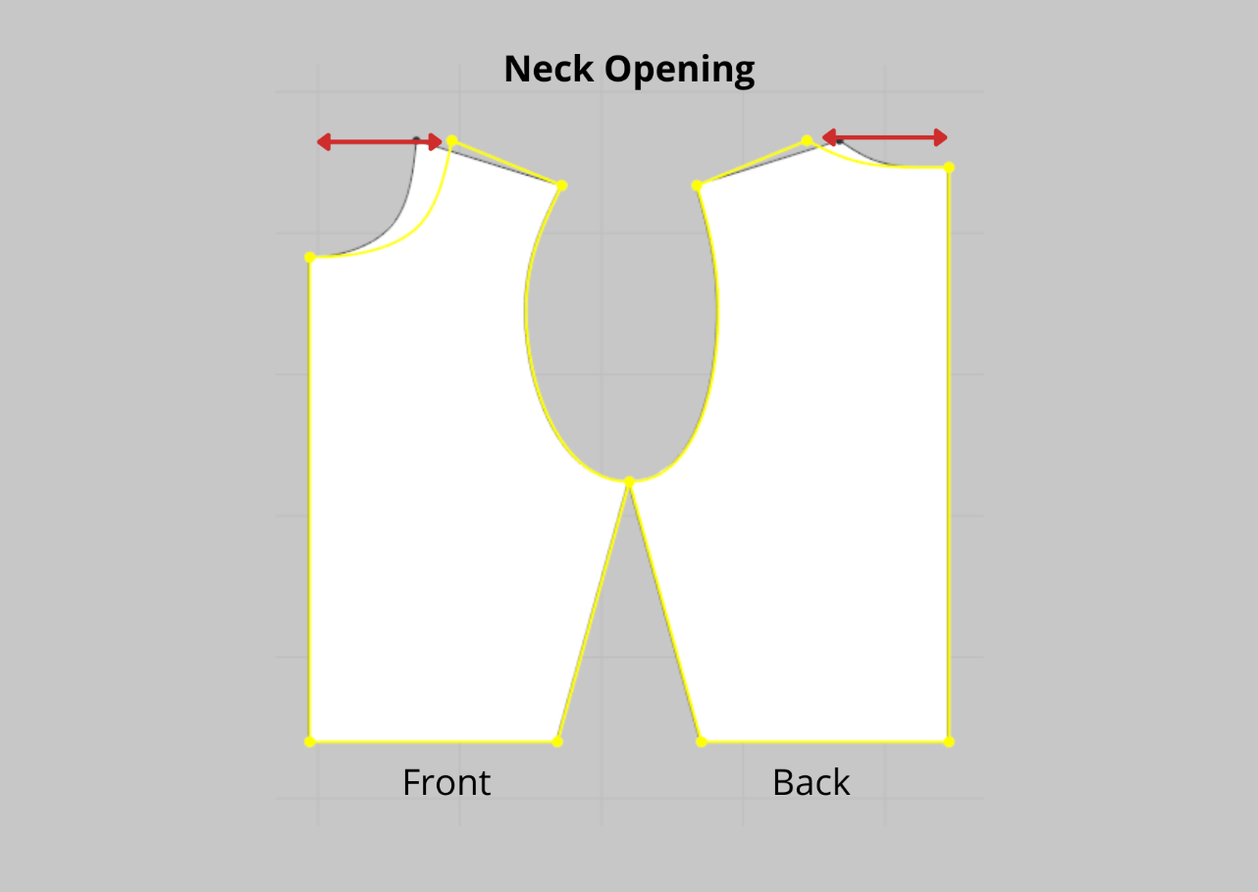

Neck Opening (Apertura del cuello)

Neck Drop (Caída del cuello)

Across Shoulder (Ancho de hombros)

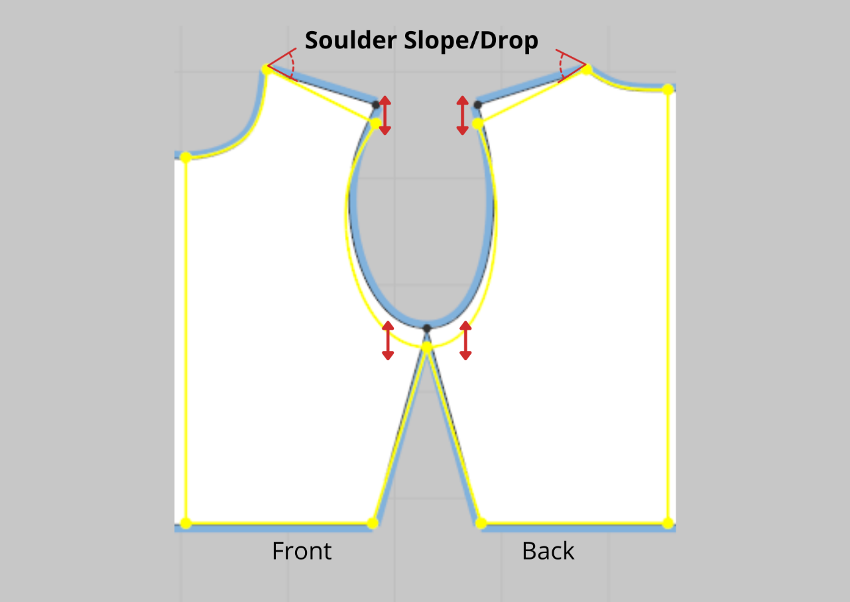

Shoulder slope/Drop (Caída del hombro (inclinación))

Across Front/Back (Ancho Delantero /Ancho Espalda)

Across Bust/Chest (Ancho de Pecho (de sisa a sisa))

Armhole Length (Recorrido Sisa)

Herm/Sweep (Dobladillo)

***Body Sleeves (Mangas del Cuerpo)***

Length Cap to Opening

Cap Height

Cap Width

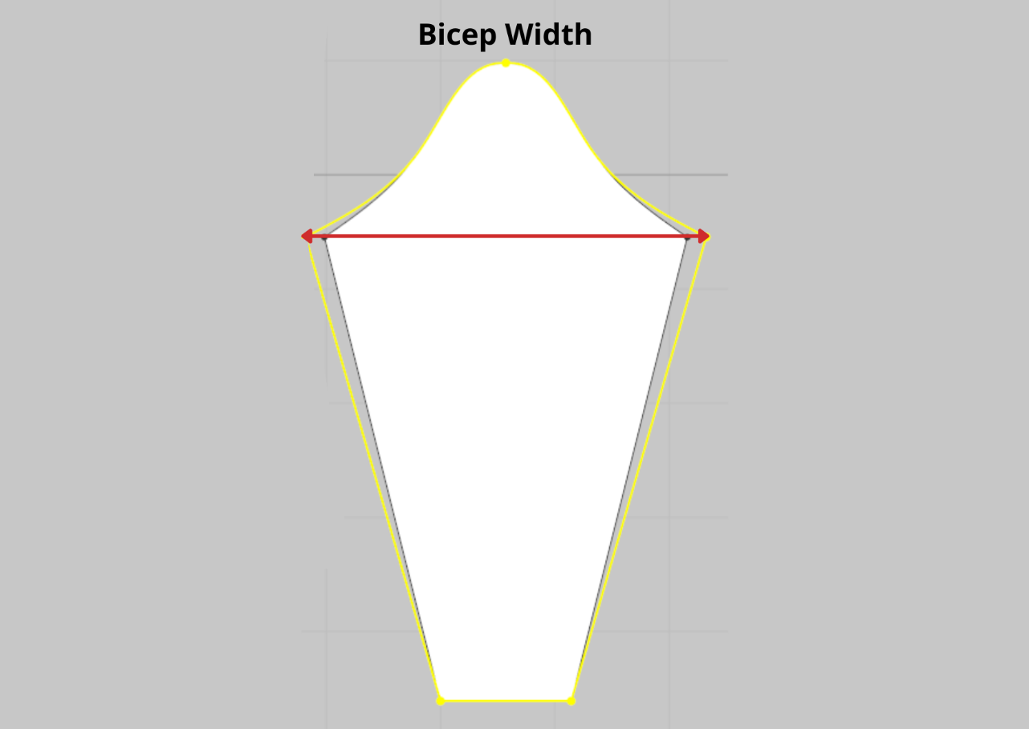 Bicep Width (Ancho de Bicep)

Sleeve Opening (Apertura de la manga)

Curvature Cameo (Edition of the curve or Grading rules)

**T-shirt Parametric Pattern Metrics in Cameo**

***Ease Settings (Holguras)***

Chest Ease (Holgura de pecho)

Waist Ease (Holgura de cintura)

Hip Ease (Holgura de cadera)

***Neckline Settings (Ajustes del escote/cuello)***

Front Neck Depth (Profundidad del cuello delantero)

Back Neck Depth (Profundidad del cuello trasero)

Neck Width (Ancho del cuello)

Neck Point (Punta del cuello)

***Settings (Ajustes)***

Shirt Length (Longitud de la camiseta)

Armhole Depth (Profundidad de la sisa)

Tummy Adjustment (Ajuste de la tripa)

Shoulder Height (Altura del hombro)

Soulder Length (Longitud del hombro)

Shoulder Point (Punto del hombro)

Cf Extension

Cb Extension

***Neckline Shape (Forma del escote/cuello) POSITION***

Front

Back

***Armhole Shape (Forma de la sisa) POSITION***

Front

Back

**Pants Parametric Pattern Metrics in Cameo**

**Ease Settings (Configuraciones de holgura)**

Waist Ease (Holgura de cintura)

Hip Ease (Holgura de cadera)

Crotch Ease (Holgura de entrepierna)

**Adjustments (Ajustes)**

Cf/Waist Drop (Caída del frente/cintura)

Cb/Waist Drop (Caída de la espalda/cintura)

Side/Waist Drop (Caída lateral/cintura)

Front Crotch Extension (Extensión del frente de la entrepierna)

Back Crotch Extension (Extensión de la parte trasera de la entrepierna)

Pant waist (Cintura del pantalón)

Hip Shape (Forma de la cadera)

Hip Depth (Profundidad de la cadera)

**Dart Length (Longitud de la pinza)**

**Dart position (Posición de la pinza)**

**Settings (Configuraciones)**

Inseam Length (Longitud de la entrepierna)

Hem Circumference (Circunferencia del dobladillo)

Knee width (Ancho de la rodilla)

Knee depth (Profundidad de la rodilla)

Panel width (Ancho del panel)

Pleat width (Ancho del pliegue)

Waistband width (Ancho de la pretina)

